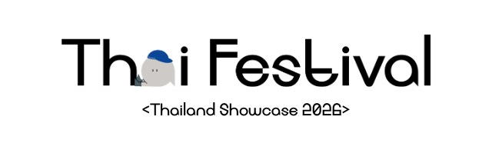

Thai Festival: Thailand Showcase 2026
“Creative Life and Creative Heartbeat”
17th – 19th July 2026
Potters Fields Park, London, United Kingdom

Vendor Application Form
Vendor Information
Business Name: ____________________________________________________________________
Contact Name: ____________________________________________________________________
Address: __________________________________________________________________________
Phone Number: _____________________________ Email: ________________________________
Website/Social media links (If applicable): _____________________________________________
Product Information
Description of products and/or services offered: _________________________________________
__________________________________________________________________________________
__________________________________________________________________________________
Do your products meet the basic criteria of being authentically Thai and showcasing innovation/creativity/craftmanship/design?
- Yes
- No
If yes, please describe how: __________________________________________________________
__________________________________________________________________________________
__________________________________________________________________________________
Required Documents
Please confirm that the following documents will be submitted to the Royal Thai Embassy at least two weeks before the event date:
- Certificate of Public Liability Insurance (Standard cover £5,000,000)
- Certificate of Employers' Liability Insurance (Standard cover £5,000,000)
- Fire Risk Assessment (If applicable)
- Risk Assessment covering all stall operation
* It is not an obligation to submit all required document at this stage. However, all documents must be submitted no later than two weeks before the event commences (3rd July 2026).
Contribution Details
Please describe the products/gifts that you will provide for the raffle or game prizes, which must be worth £400 or more: ______________________________________________________________
____________________________________________________________________________________
Would you like to provide any other in-kind contribution?
- Yes
- No
If yes, please specify: _________________________________________________________________
____________________________________________________________________________________
Additional Information
Please attach sample photos of your products and/or services and the prices. How will your products and/or services align with the event’s theme of Creative Life and Creative Heartbeat?
___________________________________________________________________________________
___________________________________________________________________________________
___________________________________________________________________________________

Are there any special requests or additional information you would like the organiser to consider?
___________________________________________________________________________________
___________________________________________________________________________________
___________________________________________________________________________________
Submission
Please submit your completed application form and required documents to Pressoffice@thaiembassyuk.org.uk by 31st March 2026.
- I hereby agree with the terms and conditions as specified in the Vendor Guide provided by the Royal Thai Embassy, London upon submission of this application.

Signature _________________________________________
Name ____________________________________________
Date _____________________________________________

**************************

Royal Thai Embassy, London
March 2026

