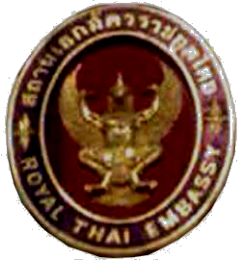

Royal Thai Embassy
No. 196 Preah Norodom Boulevard,
Sangkat Tonle Bassac,
Khan Chamkar Mon,
Phnom Penh.

Press Release

สถานเอกอัครราชทูต
ณ กรุงพนมเปญ

Tel. (855-23) 726 306 | Fax. (855-23) 726 303 | e-mail: thaipnp@mfa.go.th website : http://www.thaiembassy.org
No. 5/2548 15 February 2005

The Restoration and the Recovery of
Thai Tourism along the Coastline of the Andaman Sea

The earthquake and Tsunami tidal waves devastated the Andaman coastline in six provinces, namely Phuket, Krabi, Pang Nga, Trang, Ranong and Satun in the south of Thailand on 26 December 2004. The Royal Thai Government and Thai private sectors, in full collaboration with all Thai people have made their best efforts to restore and recover the situations in the affected areas. It is remarkable that now these areas have not only regained their original beauty, but all facilities also have been fully restored to provide a safe holiday experience for tourists.

For more information on the restoration and recovery of Thai tourism along the coastline of the Andaman Sea, please kindly click at the following websites; www.tourismthailand.org, www.andamansunshine.com, www.phuket.com, www.sawasdee.com, and www.hotelthailand.com.

********

