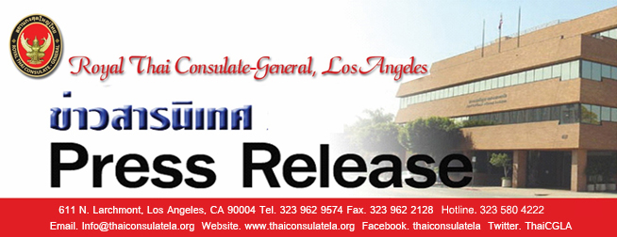

“Serving the People”

NO. 44 / 2561

Media Registration
for the ASEAN Foreign Ministers’ Retreat
on 16 – 18 January 2019, Chiang Mai, Thailand

As ASEAN Chair in 2019, Thailand will host the ASEAN Foreign Ministers’ Retreat, during 16 – 18 January 2019 in Chiang Mai, Thailand. Interested media representatives are advised to register according to the following guidelines:
1. Registration: Registration must be done online only through the ASEAN website at www.asean2019.go.th under the banner Registration > Press/Media. Registration is open from 17 December 2018 – 4 January 2019. To complete online registration, the following documents must be submitted: (1) one recent photograph (2x2 inches) (2) a photocopy of passport for foreign media or Thai Identification Card for Thai media (3) letter of assignment and (4) list of equipment (if any). Media who are not registered will not be allowed to enter the meeting premises.
2. Media Badge: Registered media must present a printed or electronic copy of the confirmation e-mail along with the original ID card or passport to collect the media badge at the Media Centre, which is located at Lanna Ballroom I, 2nd floor, Shangri-La Hotel, Chiang Mai, from 17 – 18 January 2019.
3. Hours of operation of the Media Centre are as follows:
- 17 January 2019 from 10.00 – 18.00 hrs.
- 18 January 2019 from 07.00 – 16.00 hrs.
4. The media programme will be made available and updated on the ASEAN website.
5. Further inquiries can be directed to:

Press Division, Department of Information,
Ministry of Foreign Affairs of Thailand
Tel. (+66) 2203 5000 ext. 22021, 22022
Fax (+66) 2643 5106
Email: mfathai.media@gmail.com

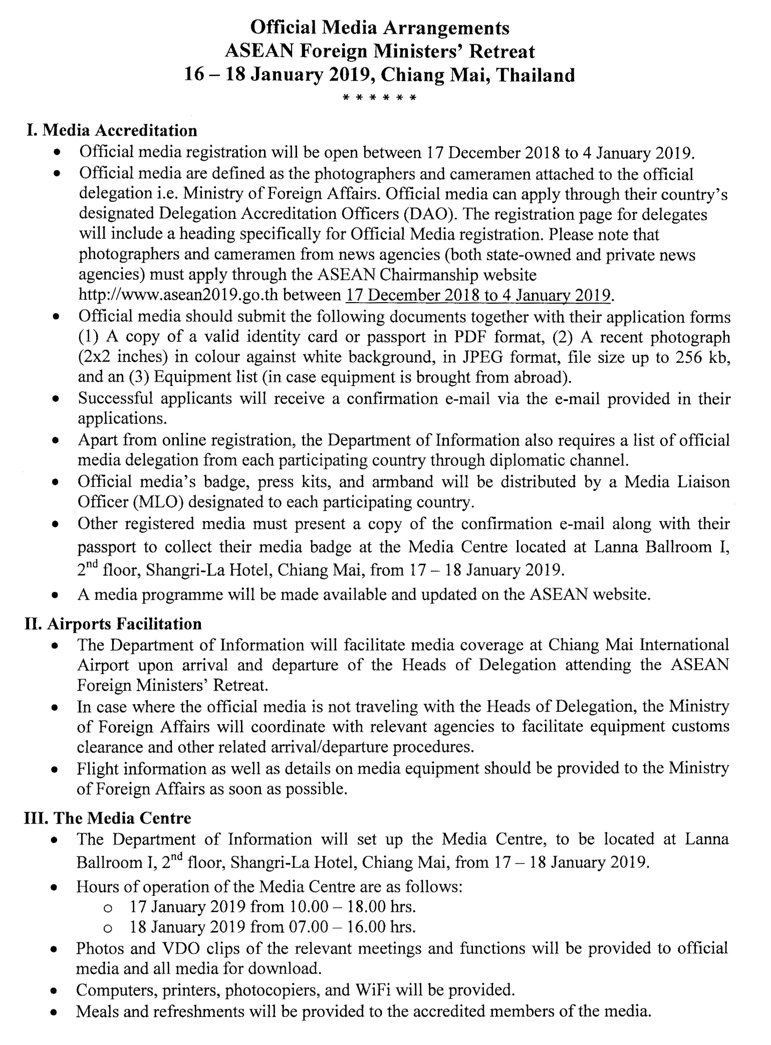

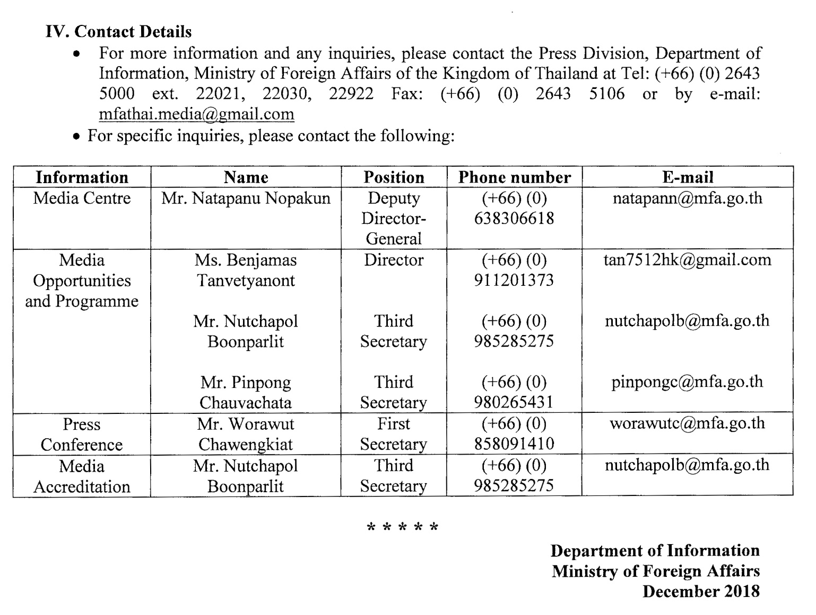

Royal Thai Consulate-General, Los Angeles
12 December 2561

