Application Form
Page 1 of 2

Logo Design Competition
70th Anniversary of Thailand-New Zealand Diplomatic Relations
Application Form

Full Name:
Nationality: | Thailand New Zealand
Gender: | Male Female Other
Date of Birth (DD/MM/YYYY): |  | Age:
Occupation: (If a student, please state current year of study and institution)
Address
Country of Residence: | Thailand | New Zealand
Mobile Phone Number:
Email Address:

Note:
- The participant hereby acknowledges that the period for submission is from 21 January to 16 February 2026 (23.59 hrs.)
- The participant is required to create one (1) logo design in colour, with vertical and horizontal versions, with and without white border (in total of 4 versions of the same logo) (See example of the ASEAN 50th Versions below). Exported as pixel based: PNG or JPEG with at least 300dpi resolution.
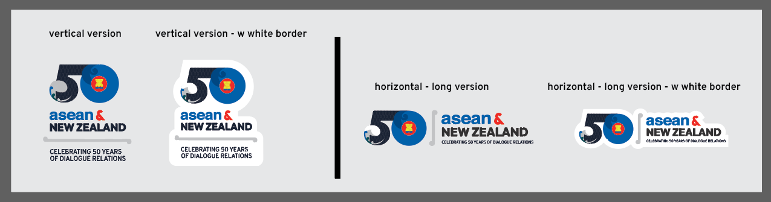
- Submit to: admin02@thaiembassynz.org.nz by 16 February 2026 (23.59 hrs.)
- The participant may submit one (1) logo only, together with the application form and brief design description explaining the inspiration, symbolism, and colour choices. Group entries are not accepted.
- The participant hereby accepts the Terms and Conditions of the logo design competition and agrees to comply with all competition rules.
- The participant grants consent to the Ministries of Foreign Affairs and Embassies of Thailand and New Zealand, as the host, to collect and retain the information above.
The participant further certifies that the information above is true, accurate and complete.
- The participant hereby confirms and accepts that the logo design submitted with this application constitutes the final version and shall not be subject to further modification or replacement.

Submission Date:……………………………….
Signature:………..……………………………….
Please continue on page 2

Application Form
Page 2 of 2
Logo Design Competition
70th Anniversary of Thailand-New Zealand Diplomatic Relations
Application Form

Brief design description (Please describe the design inspiration, symbolism of the graphic and colour choices.)
Note:
- Please ensure that the brief explanation corresponds with the final logo design submitted with the application form.

Submission Date:……………………………….

Signature:………..……………………………….

