Woojung Education and Culture Foundation | Scholarship Form
New Applicants, Spring Semester of 2021

TO THE APPLICANT

- To apply for the scholarship please submit the scholarship form.

- As long as you meet the following requirements and have been recommended by your Embassy you are eligible to apply.

- A foreign student studying in Korea seeking financial support for tuition fee and living cost. Note : One must enroll formally at a university as an undergraduate or graduate student. Students enrolled in language classes do not qualify.

- Confirm that you do not exceed the term of the scholarship (The reference start date is the date you begin school)
- Undergraduate students in 4 year university : First 8 semesters (First 4 years)
- Master’s degree students : First 4 semesters (First 2 years)
- PhD degree students : First 6 semesters (First 3 years)
- Joint Master’s and PhD degree students : First 8 semesters (First 4 years)
Note : We are unable to offer scholarships beyond the noted terms.

- A student who has acquired over 80 points score (equivalent to a grade of B) of academic records. But if the student has financial difficulties, this shall also be considered.

Note : A student must have at least one semester of grades and as a full time student from a four year Korean university to apply for the scholarship. (In order to determine academic potential).

- A student with good manners.

- A student with no government scholarship. Students receiving no scholarships from any source will receive preferential consideration when selecting Woojung scholarship recipients.

IMPORTANT DEADLINES AND DATES

- Application submission date to Embassy Follow Embassy guidelines

  - Please submit you application to your Embassy promptly, at the designated deadline.
  - The foundation will in turn evaluate all applications on January 28, 2021

- Scholarship Decision
The decision regarding the scholarship will be notified soon after.

- Scholarship Ceremony
During normal years all recipients must attend the biannual Scholarship Ceremony to receive the scholarship and certificate. But due to COVID-19, the ceremonies have all been canceled. The certificates will instead be mailed to your home address.

Woojung Education and Culture Foundation | Scholarship Form

CHECKLIST OF REQUIRED FORMS
Please check boxes to ensure application is complete.
INCOMPLETE APPLICATIONS WILL NOT BE REVIEWED

NOTE : Please pay special attention to the self-introduction, study plan and recommendation.

- Application Form
(Complete both in English and Korean)

- Certificate of Admission

- Certificate of Enrollment (Original Copy)

- Transcript (Original Copy)

- Recommendation letter by professor or dean
(Complete both in English and Korean)

- Self-Introduction
(Complete both in English and Korean)

- Study Plan for 1st semester of 2021
(Complete both in English and Korean)

- Copy of Bank Account with Account Number
(In order to wire the scholarship to recipients)

Woojung Education and Culture Foundation | Scholarship Application
COMPLETE BOTH IN ENGLISH AND KOREAN
1st Semester 2021

Name |  | Last name |  |  |  | Gender
 |  | First name
Date of Birth |  | . . . | Nationality |  |  | Student ID
School |  |  | Major |  |  | GPA at last semester
Address in Korea |  | Please write in Korean (We need complete Korean address to send certificate)
Native Country Address
E-mail |  |  | Mobile  (Korea) |  |  | Native country  Phone No.
Father |  | Name  (Native name)
 |  | Nationality
 |  | Job/Position
Mother |  | Name  (Native name)
 |  | Nationality
 |  | Job/Position
Bank |  |  | Account
Depositor |  |  | Relationship with  depositor | Father, Mother, Him / Her self
I am applying for the Woojung Education and Culture Foundation scholarship for the 1st Semester of 2021.
I will return the scholarship award if I give up my studies during the semester or if I cannot complete the coursework without adequate reason. I confirm that the information given in this form is true, complete and accurate.
2021 . . .

Applicant : (signature)
Enclosure | 1. Application Form  3. Certificate of Admission  5. Transcript  7. Study Plan |  |  |  | 2. Recommendation Letter  4. Certificate of Enrollment  6. Self-Introduction  8. A Copy of Bank Book

우정교육문화재단 장학금 신청서
COMPLETE BOTH IN ENGLISH AND KOREAN
2021년도 제 1학기

성명 |  | 성 |  |  |  | 성별
 |  | 이름
생년월일 |  | . . . | 국적 |  |  | 학번 | . . .
학교 |  |  | 전공 |  |  | 직전학기  평점평균
한국 주소
모국 주소
이메일 |  |  | 휴대폰번호  (한국) |  |  | 모국 연락처
부 |  | 성명  (원어 성명)
 |  | 국적
 |  | 직업/직책
모 |  | 성명  (원어 성명)
 |  | 국적
 |  | 직업/직책
은행 |  |  | 계좌번호
예금주 |  |  | 예금주와의 관계 | 부, 모, 본인
2021학년도 2학기 우정교육문화재단 장학금을 상기와 같이 신청하며, 만일 중도에 학업을 포기하거나
과정을 이수하지 못한 경우에는 수령한 장학금을 반환하겠습니다.

상기의 기재내용에 이상이 없음을 확인합니다.
2021 . . .
신 청 인 : (인 또는 서명)
첨부서류 | 1. 신청서 1부  3. 입학허가서 1부  5. 성적증명서 1부  7. 학업계획서 |  |  |  | 2. 추천서 1부  4. 재학증명서 1부  6. 자기소개서  8. 장학금 수령 통장 사본 1부
Certificate of Admissions (Sample)

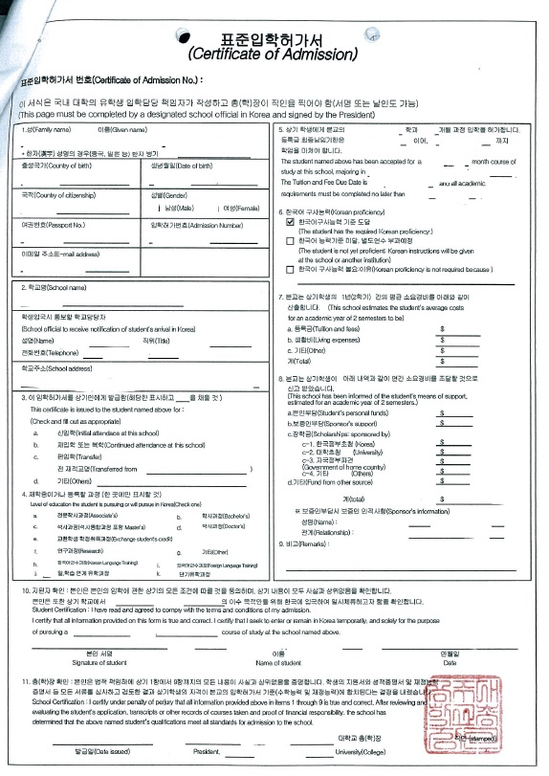

Certificate of Enrollment

Official Academic Record

Recommendation for Scholarship
Woojung Education & Culture Foundation

【 Student 】
Name :
Nationality : |  | Date of birth :
School : |  | Major :
【 Recommender 】
Name : |  | Tel :
Institution : |  | Position :
Recommendation :

※ Please provide your comments on recommendee's living condition, school attitude, personality, vision etc.
※ The recommender should be the one among professors, deans, or presidents, if it's from schools, or the someone
recommended by the organization that the Foundation approved.

I recommend the above student for scholarship of Woojung Education & Culture Foundation in 1st Semester, 2021

. . .

Recommender : signature

우정교육문화재단 장학생추천서
【 학생 인적 사항 】
성 명
국적 및 생년월일 | 국 적 : 생년월일 :
소 속 | 학교명 : 학과(계열)명 :
【 추 천 인 란 】
성 명 |  | 연 락 처
소 속 |  | 직 위
추 천 내 용

※ 추천 대상자의 생활환경, 학업태도, 인성, 비전 등에 대해 추천인의 의견을 기재하여 주시기 바랍니다.
※ 대학교의 경우 지도교수, 학장, 총장 또는 기타 재단이사 2명 및 사회저명인사 추천.

위 학생을 2021년도 제 1학기 우정교육문화재단 장학생으로 추천합니다.

년 월 일

추천인 : (서명)

Self Introduction for 1st Semester 2021

COMPLETE BOTH IN ENGLISH AND KOREAN

Our objective isn’t to grade your Korean proficiency.
So if you have difficulty with Korean please have your English self introduction translated into Korean.

Study Plan for 1st Semester 2021

COMPLETE BOTH IN ENGLISH AND KOREAN

Our objective isn’t to grade your Korean proficiency.
So if you have difficulty with Korean please have your English self introduction translated into Korean.

