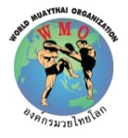
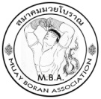

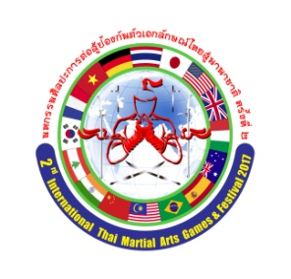
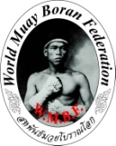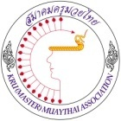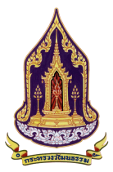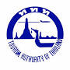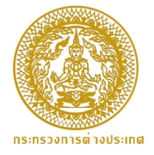

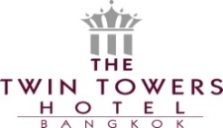


WE ARE PROUD TO INVITE YOU TO
มหกรรมศิลปะการต่อสู้ป้องกันตัวเอกลักษณ์ไทยสู่นานาชาติ ครั้งที่ ๒
THE 2ndINTERNATIONAL THAI MARTIAL ARTS
GAMES AND FESTIVAL 2017
With the support by the Thailand Tourism Authority (T.A.T)
13th WORLD WAI KRU CEREMONY
17 MARCH 2017, AT THE WORLD HERITAGE SITE
ANCIENT CAPITAL OF (PRANAKORN SRI AYUTTHAYA)
12th- 22ndMarch 2017
NIMIBUTR STADIUM,Bangkok, Thailand
2nd Angel Warrior World Championships
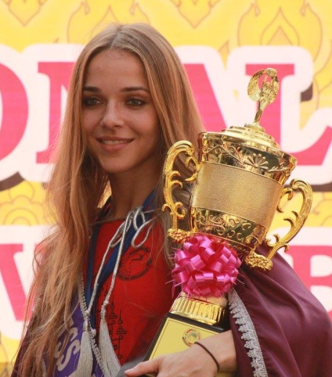

ALL APPLICATION FORMS AND ALL DETAILS TO
(GRAND MASTER KEVIN)
For all details contact WMBF VP Grand Master Kevin E: siamkev@hotmail.com T:+447850 544148
GRAND MASTER CHINAWUT SIRISOMPAN (GM. WOODY)
Please send a copy of all Information to: Email gmaster_woody@hotmail.com
