Official Request for World Friends KOICA Volunteer

1. Summary of Request

<Introduction of KOICA Volunteer >
KOICA Volunteer: Junior expert with educational or career experiences in the field.

Name of country |  | Name of institution
Category | Public administration( ), Education( ), Technology, Environment and Energy( )  Agriculture/forestry/fisheries( ), Healthcare( ),
Job title | *Please choose one of the job titles that KOICA provide in the job description file.
Contact information  of institution | Address
Contact information  of institution | Phone |  | Email

2. Overview of Institution for Dispatch of KOICA Volunteer

1) Purpose of Institution establishment and major tasks

Purpose of Institution establishment :

Major tasks :

2) Work days and hours of Institution :

3) Case of cooperation with an institution other than KOICA for the last two years from the date of survey
- Name of country (or multilateral organization) :
- Name of institution (or multilateral organization) :
- Number of dispatched volunteer :
- Main activities (Please write briefly) :

4) Benefits of ODA program/project
(※ Describe the name of donor country, executing institution, name/period of program/project)

5) Information on co-worker of KOICA Volunteer
- Name: , Position:

Phone: , Email :

3. Activity Information of KOICA Volunteer

1) Form of dispatch : New( ), Successor( )
* Mark on “successor” if any KOICA volunteer has been dispatched in the same position over the last two years.

2) Expected activities after dispatch of KOICA Volunteer
※ Please describe exact details of activities, activity days /hours, target, number of participants

- Working day: Monday( ) Tuesday( ) Wednesday( ) Thursday( ) Friday( ) Saturday( ) Sunday( )
- Target hours: ______hour/day and ________hour/week
- Target beneficiary: ________________________ / Number of beneficiaries: ___________
- Purpose of request of KOICA volunteer

- Tasks that the volunteer will carry out

- The goals intended to be achieved through the activities of volunteer

3) Project Design Matrix (Optional)
Inputs | Activities | Outputs
[Volunteer/KOICA]  [Volunteer Hosting Organization] | 1-1. | Output1-1.
[Volunteer/KOICA]  [Volunteer Hosting Organization] | 1-1. | Verifiable Indicator
[Volunteer/KOICA]  [Volunteer Hosting Organization] | 1-2. | Output1-2.
[Volunteer/KOICA]  [Volunteer Hosting Organization] | 1-2. | Verifiable Indicator
[Volunteer/KOICA]  [Volunteer Hosting Organization] | 2-1. | Output2-1.
[Volunteer/KOICA]  [Volunteer Hosting Organization] | 2-1. | Verifiable Indicator
[Volunteer/KOICA]  [Volunteer Hosting Organization] | 2-2. | Output2-2.
[Volunteer/KOICA]  [Volunteer Hosting Organization] | 2-2. | Verifiable Indicator

4) Language
- Language required for official activities:
- Language required in daily life :

5) Availability of office and office supplies (Please be specific, e.g. computer, printer, telephone, etc.)

Office space ( ), desk/chair ( ), computer ( ), printer( ), telephone ( )
Other providable supplies ( )

4. Required qualification for KOICA Volunteer

1) Sex : M( ), F( ), Any( ) / Choose one

2) Education : Meister or specialized high school( ), Associate of Arts( ), Bachelor( ), Master( ), any( )
*Please choose only one option that represents the minimum requirement for the volunteer’s activities.

3) Work experience:
Not necessary( ) Over 6 Month( ) 1 years( ) 2 years( ) 5 years( ) 10 years( )
*Please choose only one option that represent the minimum requirement for the volunteer’s activities.

4) Age : Up to 50 years( ), 55 years( ), 60 years( ), 65 years( ), 70 years( ), No Upper Age Limit ( )
*Please choose only one option that represents the minimum requirement for the volunteer’s activities.

5. Local and living information

Location on the map | 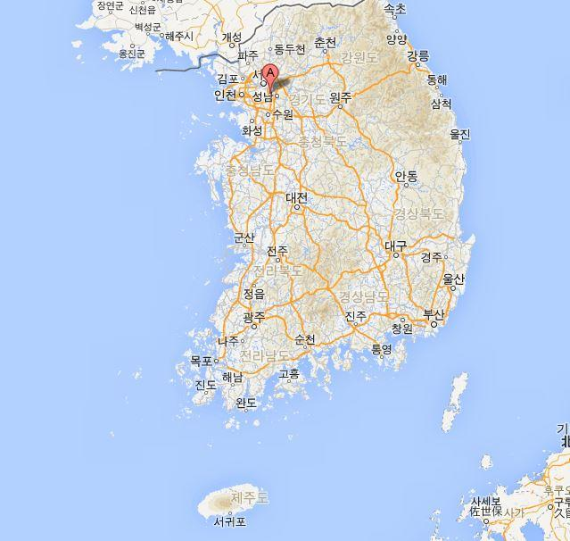  *Please insert the google map link if possible.
Local population | ( ) | Distance from the capital | Km
Size of city | Metropolis( ), Medium-sized city( ), Town ( ) | Means of transportation to the capital | Airplane( ), Automobile( ),  Train( ), Bus( )
Living expenses/month | US$ | Travel time to the capital | ( ) hr, ( ) min
Living expenses/month | US$ | Housing expenses/month | US$
Housing | Provided by Institution ( ) | Domitory ( ) House ( ) Apartment ( )  Official residence ( ) Others ( )
Housing | Not Provided( )
Electricity | 110v ( ), 220v ( ),  Both ( )  Frequency of blackout( )  Duration of blackout( ) | Heating/Cooling | Heater available ( )  Air-conditioning available ( )
Safety conditions | Very safe( ),  Safe( ),  Dangerous( ),  Very dangerous( ) | Medical facilities | General hospital( )  Hospital( )  Health center( )  N/A( )
Vaccination requirements
Other useful information | additional information, e.g. supplies, materials to prepare before departure

I hereby submit the official request form to World Friends KOICA Volunteer

(Name) :
(Position) :
(Institution Name ) :
(Date) : DD/MM/YYYY
(Signature) :

