Thailand International Cooperation Agency (TICA)
and Department of Disease Control
present this certificate to
Ms. ……………………(Name of Participant)………………………
in recognition of successful completion of the Annual International Training Course on
Management of Antiretroviral Treatment and Long-Term Adherence to ART 15-26 May 2018
Conducted by Department of Disease Control, Ministry of Public Health
Given on 18 May 2018

(Ms. Pattarat Hongtong)
Director – General,
Thailand International Cooperation Agency,
Ministry of Foreign Affairs

(Mr. Suwannachai Wattanayingcharoenchai)
Director – General,
Department of Disease Control,
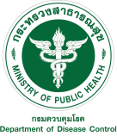
Ministry of Public Health

