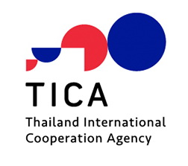

Proposal Form for Study Visit Project/Bilateral Project
Under the 23rd Session of the Sino-Thai Joint Committee
on Scientific and Technical Cooperation

1. Requesting Agencies
1.1 Thai Implementing Agency :
…………………………
1.2 Chinese Implementing Agency (if any) :
…………………………….

2. Coordinating Officer(s)
2.1 Thai Coordinating Officer(s) :
Name(s) :
Position :
Address :
Tel. No. :
Fax No. :
Email :

2.2 Chinese Coordinating Officer(s) (if any) :
Name(s) :
Position :
Address :
Tel. No. :
Fax No. :
Email :

3. Title of the Study Visit (in English) :
Title of the Study Visit (in Thai) :

4. Sector of the Study Visit :

5. Background and Rational :

6. Purposes of the Study Visit :

7. Proposed Activities :

8. How would the proposed activity be integrated into the work plan and mechanism of the requesting organization to ensure sustainability?

9. Number of Participants (maximum of 6 people) :

10. Venue :

11. Estimated Start and Finish Dates (maximum of 5 days excluding travel days) :

12. Funding Requests (please attach the details of the project’s financial requests) :

*********************************

