Tamil Nadu’s Economic Fact Sheet (Last updated 18/05/2015 by Pornpimol)
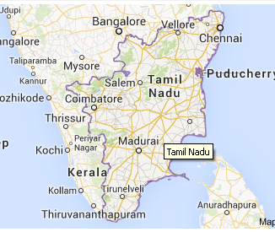 |  | 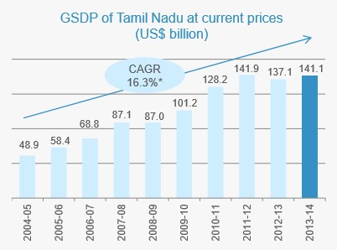
  Tamil NaduFact file
  Capital | Chennai
  Geographical area (sq km) | 130,058
  Administrative Districts (no) | 32
  Total population (mil) | 72.15
  Male population | 36.13
  Female population | 36
  Literacy rate (%) | 80.09
  Gross State Domestic Product (GSDP) US$ billion | 137
  GSDP (Growth) 2013-2014 | 16.3%
  Per Capita GSDP (2013)US$ | 2,059.3
  Exports (2013-2014) US$ bil | 35.9
  FDI Inflows (2013-2014) bil | 15.9
  Gross State Domestic Product (bil)
Exports (US$ Billion) | FDI Inflow and Investment By Sectors (%) | Tamil Nadu Advantage
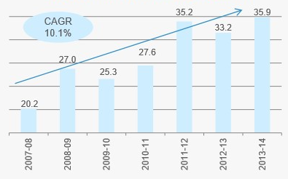 | 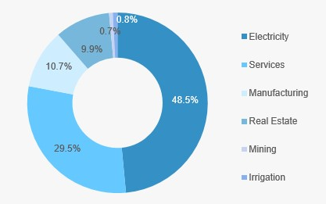 | -4th largest state of India and contributed 8.1% to India’s GDP  -ranks 3th in terms of investment  -ranks first among states in terms of number of factory and industrial workers  -Chennai is dubbed as “Detroit of India”  -ranks 2nd in software exports  -key financial center in South India  -ranks 3rd in India in terms of domestic tourist arrival and second in foreign tourist arrival
Physical Infrastructure | Installed Power Capacity (MW) | Telecom (Nov. 2014)
Road: US$ 500 million World Bank Funded project to upgrade road infrastructure and US$ 27.7 billion for improvement of highways (Vision 2023)  Rail: Mass-Rapid-Transit System (MRTS) in Chennai (25 km) under construction and US$ 27.5 billion key rail project (Vision 2023)  Airport: International Airport – Chennai (12.8 million passenger), Coimbatore, and Trichy and US$ 5.2 billion for developing a Greenfield airport near Chennai and upgrading other airports  Port: three major ports – Chennai (handles container cargo), Ennore and V O Chaiambaranar (handles coal, ores and other bulk minerals) | 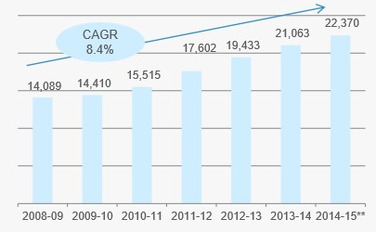  From total Installed power generation capacity, 11,126 MW was contributed by thermal power and renewable power contributed 8,075 MW. Hydropower and nuclear power contributed 2,182.2 MW and 986.5 MW of capacity.  Tamil Nadu Vision 2023 envisages an investment of US$ 39.6 billion to expand generation capacity by 30,000 MW.
  Wireless Connections | 79,931,918
  Wire-line Connections | 2,790,217
  Broadband subscribers | 2,859,000
  Major operators: Bharat Sanchar Nigam Limited (BSNL), Bharti Airtel, Aircel Limited, Reliance Communications, Vodafone Essar, Tata Teleservices, Idea Cellular
  Key Player in IT and ITes Industry
  Mahindra System
  Tata Consultancy Services (TCS)
  Infosys Technologies
  HCL Technologies
  Key Player in Auto Industry
  Ford Motor Company
  Hyundai Motor India Ltd (HMIL)
  Mitsubishi Motors Corportation
  Ashok Leyland
  Key Player in Engineering Industry
  Amalgamations Group
  Bharat Heavy Electricals Ltd (BHEL)
  TVS Group
  Greaves Cotton Ltd
  Tourist Arrivals in Tamil Nadu (mil)
  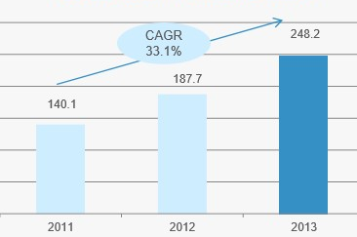
  Key Investment Promotion Office
  -Tamil Nadu Industrial Development Corporation Ltd (TIDCO)
  -State Industries Promotion Corporation of Tamil Nadu (SIPCOT)
  -Tamil Nadu Industrial Investment Corporation LTD (TIIC)
  Diplomatic Mission in Chennai
  45 foreign Representation in Chennai
  12 Consulate-Generals and High Commission: Australia, Belgium, Germany, Japan, Malaysia, Russia, Singapore, South Korea, Sri Lanka (Deputy High Commission), Thailand, United Kingdom (Deputy High Commission), United States
  Flight Bangkok-Chennai
  Air Asia  Sunday, Monday, Wednesday, Thursday, Friday) except Tuesday, Saturday | BKK-MAA FD153  19:45-21:35 hrs.  MAA-BKK FD154  22:25-03:20 hrs
  Thai Airways International (Everyday) | BKK-MAA TG337  21:50-23:40 hrs  MAA-BKK TG338  00:55-05:55 hrs.
  Cost of Doing Business in Tamil Nadu
  Industrial land (per sq ft) | US$ 5 - 120
  5-star hotel (room/night) | US$ 100-300
  Office space rent (per sq ft/month) | US$ 0.7 – 3.1
  Residential space rent (2,000 sq ft house) | US$ 350- 1,540 per month
  Power (per kWh) | Com: 14.5 cents  Indt: 11 cents  Dom: 3.8 cents
  Labor (min wage/ day) | US$ 1.9 – 7.9

