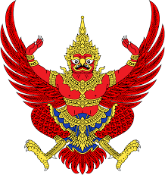

**MESSAGE OF CONDOLENCE**

The Royal Thai Embassy in Budapest has learned with great sadness of the fateful road accident and untimely passing of several students and faculty members of the Keruleti Szinyei Mares Pal Gimnazium of Budapest on the evening of 21 January 2017 in Verona, Italy.

The Royal Thai Embassy and the Thai community in Budapest wish to express to the people of Hungary, and the bereaved families affected by the accident and sudden loss of their loved ones, our most sincere condolences for their loss during this time of grief. The staff of the Royal Thai Embassy and the Thai people in Hungary pray in solidarity with the people of Hungary during this time of national mourning.

May their gentle souls forever remain in our hearts as they rest in peace.

Royal Thai Embassy,

Budapest.

23 January B.E. 2560 (2017)